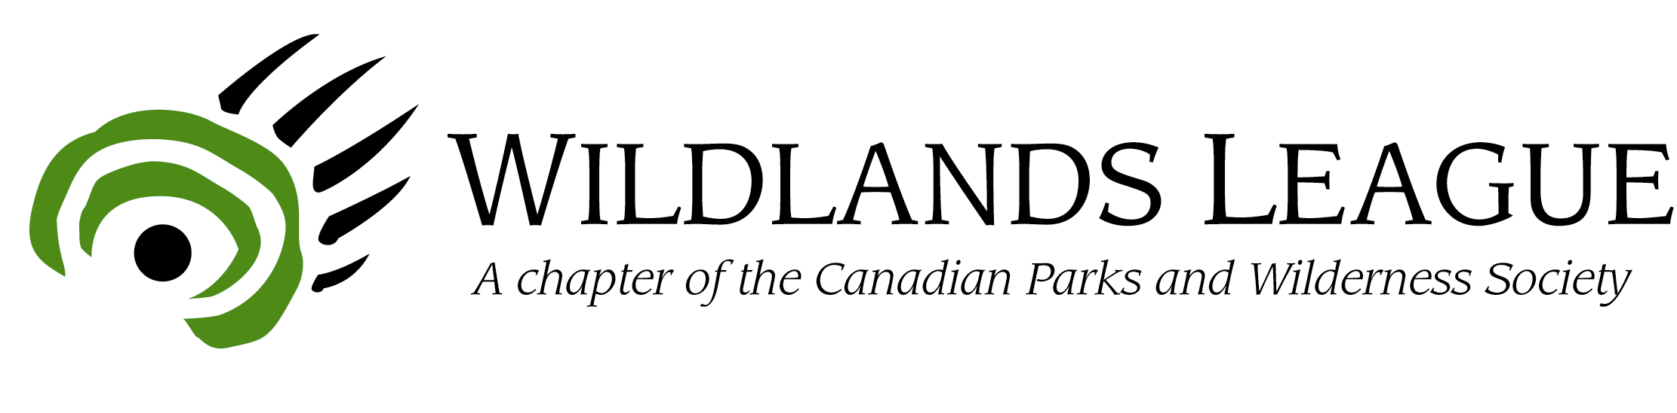

May 18, 2005

Act now or lose Ontario’s northern boreal wilderness:
Public campaign begins today

Toronto, Ont. – In an open letter to Premier Dalton McGuinty, conservation groups are warning that, without action, Ontario’s northern boreal wilderness – part of the largest continuous stretch of Canada’s boreal forest region – is in danger of irreversible harm. In the letter, endorsed by ten other conservation groups, CPAWS-Wildlands League is asking the Premier to place an immediate moratorium on proposed developments in the intact Boreal region north of the 51st parallel, until plans are completed that protect nature and provide for sustainable economic development.

At a Queen’s Park news conference today, CPAWS-Wildlands League released the letter and dramatic new maps demonstrating the combined threats from potential industrial developments and road networks in Ontario’s northern Boreal region. The region starts roughly at the 51st parallel and ends at Hudson’s Bay, covering 370,000 km² of intact wilderness – an area larger than Nova Scotia, New Brunswick and P.E.I. combined.

“We risk liquidating our natural capital in Ontario’s northern Boreal region if we don’t plan before development decisions are made” says Wendy Francis of CPAWS-Wildlands League. “We’re talking about a significant portion of Canada’s entire intact Boreal area - the second largest remaining wilderness forest in the world,” she adds. More than one-half of Ontario’s Boreal landscape, which covers 70 percent of the province, has already been fragmented because commitments to industry were made before planning for conservation.

Pointing to development proposals now underway or being considered, such as De Beers’ Victor Diamond Mine near Attawapiskat, coal-bed methane exploration 100 km northeast of Hearst, proposed east-west hydro-electric transmission lines that could bisect up to 1,000 km of intact forest, a proposed all-weather road network, and several potential forestry allocations, Francis says the danger is imminent, but can be avoided if action is taken now.

“We believe that sustainable northern economies and healthy ecosystems go hand in hand,” notes Francis, “The best way to achieve this is to implement a new approach in partnership with Aboriginal peoples and governments where comprehensive land use planning occurs before development.”

Today’s news conference marks the beginning of a public campaign by CPAWS-Wildlands League to conserve Ontario’s northern Boreal wilderness. Public educational materials and events and an interactive website at www.borealmajesty.org will all help to deliver the message to citizens and the government that Ontario needs to take action now to conserve its northern Boreal wilderness, before the opportunity is lost forever.

“Our message is: don’t foreclose on the opportunity to both protect nature and ensure sustainable communities by rushing into new industrial activities now, before there is a coordinated means of planning to conserve all of the land’s values,” says Francis.

The groups are asking the Premier to live up to a commitment he made in 2003 to “institute meaningful, broad-scale land-use planning for Ontario’s Northern Boreal Forest before any new major development… (that will) protect the ecological integrity of this natural treasure and help provide a sustainable future for native people and northern communities.” They have requested the Premier’s response by June 15th.

In the groups’ letter to the Premier they state: “Allowing Ontario’s northern Boreal forests to be developed without conservation-based planning will permanently put species-at-risk such as Woodland caribou and wolverine, in greater danger, driving them closer to extinction. Populations of these animals already have been largely driven out from more southern regions by improperly planned logging, mining, hydroelectric, road development and fire suppression.”

Ontario’s northern Boreal forests are home to 28 Aboriginal communities, many of whom maintain strong ties to the land. The region also supports populations of valuable furbearer species, such as beaver and American marten. Moose, black bears, lynx and wolves also make their homes in the northern forests. The boreal region supports crucial breeding habitat for hundreds of millions of songbirds and waterfowl, and its wild river and lake systems support more than 60 species of fish and many fly-in fishing businesses that employ hundreds of people.

CPAWS Wildlands League is a chapter of the Canadian Parks and Wilderness Society and has been advocating on behalf of nature in Ontario for 35 years. As a member of the Boreal Leadership Council, CPAWS Wildlands League is a signatory to the Boreal Conservation Framework. Developed by conservation groups, First Nations and industry, the Framework calls for a new approach to conservation in Canada’s entire boreal, including effective land use planning.

To view today’s maps, letter to the Premier, and other campaign information, visit www.borealmajesty.org.

-30-

Contact: Wendy Francis
Strategic Advisor
CPAWS-Wildlands League
(416) 971-9453, ext. 26
wendyleefrancis@cs.com
www.wildlandsleague.org

