+Proposal for a Manitoba Hydro Cable under Lake Winnipeg
John Ryan
Winnipeg Free Press, February 9, 10, & 11, 2008


Retired professor John Ryan believes a transmission line buried under Lake Winnipeg would be more cost effective than a west route and less damaging to the environment than either the east or west routes. This is the first part of his three part series.
PART ONE
Hydro Transmission cable under Lake Winnipeg explained
HAS Manitoba Hydro fully investigated an alternative to both the east and west routes for Bipole III — an underwater route through Lake Winnipeg? From what has been made public, it appears that it has not.
The recently released Bipole III Transmission Routing Study, a consultant’s report commissioned by Manitoba Hydro, makes no mention of a possible underwater route.
The purpose of this article is to bring to the public’s attention the fact that a third alternative does exist, and that it might be superior to the two hotly contested land routes. This might very well be a win-win solution and an idea whose time has come.
In a Dec. 9 news report, “No need to pick sides, just go underwater,” Free Press, Bob Brennan, Hydro CEO, dismissed the idea of a hydro line under Lake Winnipeg as being “unbelievably expensive.”
He claimed that Hydro’s engineers determined that an underwater line would cost four to six times as much as running it on steel pylons above ground. Hydro’s estimate was that an underwater route, at a minimum, would cost $3 million per kilometre and it could exceed $4.8 million.
The recently installed 580 kilometre cable laid under the North Sea between Norway and the Netherlands (NorNed), however, cost $1.5 million per kilometre — half to one third the cost cited by Mr. Brennan.
This figure of $1.5 million per kilometre was confirmed by Thomas Worzyk, the technical project manager for ABB Power Technologies company in Sweden. The firm manufactured most of the cable, and installed the entire NorNed underwater line, including two converter stations, at a total cost of $870 million.
If the converter costs are removed from the NorNed equation, the cost per kilometre can be estimated to fall to about $750,000 per kilometre, which is less than the $806,000 per kilometre that Mr. Brennan says it will cost to string the line down the west side of Manitoba.
“A two-million Euro ($3 million) price tag on one kilometre of submarine cable seems unrealistically high to me,” Mr. Worzyk said.
Moreover, at a legislative committee meeting on Dec. 19, Mr. Brennan stated that underwater cable would be at least 10 times the cost of overhead lines. Were these various figures the product of flawed research, or were they just pulled out of the air?
It should be emphasized that an underwater cable is not some experimental project. Thousands of kilometres of underwater cable have been installed throughout the world during the last half century.
Installation costs were a major factor in the North Sea project, but on shallow Lake Winnipeg costs would be significantly less, perhaps $500,000 per kilometre, according to a knowledgeable source.
So it would appear that underwater cable is much less expensive than Mr. Brennan claims. The next question is, how would it be done?
If we were to run a cable under Lake Winnipeg, it would appear that the most logical route would be from Warren Landing in the north to Traverse Bay in the south — a distance of 350 kilometres. Based on the estimate of $500,000 per kilometre, our costs for 350 kilometres would work out to $175 million.
The NorNed North Sea cable, however, was a 700 megawatt cable. Manitoba Hydro proposes that the capacity be 2,000 megawatts.
No problem. According to my research, a 1,000 megawatt underwater cable should cost about $250 million. Two sets of 1,000 megawatt cables would give us the 2,000 megawatt capacity that Hydro wants for its new line — at a cost of $500 million or $1.4 million per kilometre. Although these are well based estimates, the actual costs could be determined only by a budgetary tender.
In addition to the underwater portion, there would be the costs for the overland distance of 450 kilometres. This would be from Gillam to Warren Landing — 363 kilometres — plus 87 kilometres from Traverse Bay to Riel, where a converter station could be built. Based on Manitoba Hydro’s East route projected cost of $758,192 per kilometre, the land route would cost $341 million.
In summary, the costs of the Lake Winnipeg underwater route could be $1.1 billion for two converters, $500 million for the underwater cable, and $341 million for the land route portion — for a total of $1.9 billion.
This would be 14 per cent less than the projected $2.2 billion for the currently preferred west route and two converters — a saving of $300 million.
There would, however, be other costs (transportation of cable, for example) in the range of about $100 million, raising project costs to $2 billion and resulting in a net potential saving of $200 million. These other costs will be explained in parts two and three of this series.
On a further matter, Mr. Brennan asserted at the legislative committee meeting that underwater cables are not produced in long sections, hence many splices are required, which is time consuming, costly, and makes the line less reliable.
Mr. Worzyk refuted this saying that the cable lengths for the NorNed project ranged from 45 kilometres to 154 kilometres in length, with most sections being 75 kilometres long.
Moreover, he pointed out that jointing or splicing the cable is a standard procedure and that this “does not make the line less reliable.” There are only eight sections in the entire 580 kilometre length of the North Sea cable, which resulted in only seven splices.
As for the Mr. Brennan’s assertion that “it is an oil-filled cable so there’s environmental concerns” — this is so far removed from reality it verges on nonsense. ABB cable has no free oil inside (in contrast to standard oil-filled cables) and it has been installed in some of the most sensitive marine environments. By design, there is no environmental risk.

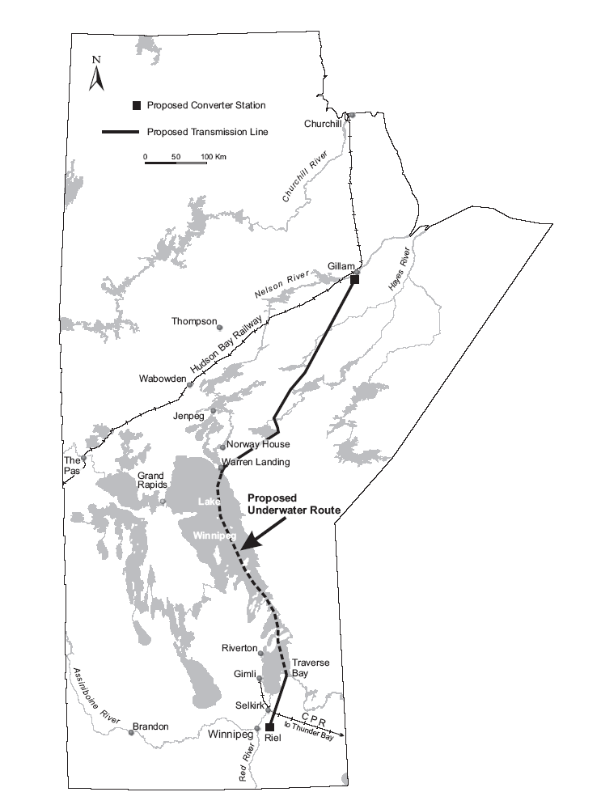
As shown on the accompanying map, the overland portion associated with the Lake Winnipeg underwater route would go through only the northern part of the designated east route, and it would bypass First Nations’ territories.
It would affect only 363 kilometres of boreal forest, as compared to the 885 kilometres for the east route and 812 kilometres for the west route. To so dramatically reduce the amount of boreal forest to be traversed is a matter of considerable consequence.
A transmission line under Lake Winnipeg would have many advantages:
* Being geographically separated from the two existing lines, it would increase the reliability and security of the entire system.
* Being 40 per cent shorter than the West route, it would significantly reduce line losses, with savings of a reported $250 million over the lifetime of the line.
* In terms of construction, the 350 kilometre lake section would require a far smaller labour force, and because of its shorter distance, the overall project would be less costly than the west route and competitive with the east route.
* It would take far less time to complete the project.
* It would cross only the northern part of the east route and it would not disrupt the overall integrity of the relatively undisturbed boreal forest.
* Compared with the east route, it would eliminate years of protracted negotiations with First Nations.
But it’s not as simple as this — there would be some additional costs to those outlined above. For the North Sea project the cable was loaded on a ship directly from the seaside factory at Karlskrona, Sweden. A short distance from there the ship proceeded to lay the cable on the seabed.
Not so with this project. A ship could bring cable to Thunder Bay, and from there it would need to be transported to Gimli by rail and then laid in the lake by barge, which will have to be built. This is doable, both technically and economically, as I will explain in the second and third parts of this series.

PART TWO
From ship to shore, two-kilometre train needed to move transmission cable
Feb 10 2008
TO bury a hydro transmission line under Lake Winnipeg at less cost than overland routes will involve some techniques that have never been used in the world before.
So far, all underwater cables have been laid in coastal areas, with the most ambitious project being the recently completed NorNed line through the North Sea between Norway and the Netherlands.
Lake Winnipeg, however, is in the interior of a continent, with the most convenient port being at Thunder Bay, 720 kilometres away.
How to get the cable from there to here?
Assume for the sake of argument that we buy the cable from ABB Power Technologies Co. of Sweden, the company that completed the NorNed line at a cost per kilometre that is significantly cheaper than Hydro claims it would be. A ship would transport it from ABB’s plant at Karlskrona to Thunder Bay, and then it would have to be brought by rail to Gimli. It is the transport from Thunder Bay to the lake and later the laying of the cable that could present challenging problems.
For our purposes it appears that we should use a cable similar to the types that were used in the NorNed project — two pairs of single-core HVDC cables, designed to operate at 1,000 MW, with voltages of +/- 500 kV, and with power losses of only 3.7 per cent.
Because of the cable’s particular design and being sheathed in lead, whereupon it is further sealed and protected, it has an extremely low electromagnetic field which otherwise could be harmful to marine life. Moreover, the cable would be buried in a trench, as deep as would be considered desirable, using proven technologies.
It should be noted that the primary purpose of the new line, according to Hydro, is “to enhance the reliability of the existing power system” and act as a back-up to the overall system. In light of this significant factor, an underwater cable would provide far greater security of supply than either the east or the west route since they would be just as prone to natural disasters as the current two land routes — disasters such as this summer’s category F-5 Elie tornado, the storm of 1996, or the great Quebec ice storm of 1998 — while underwater cable would not.
The cable would extend from Warren Landing at the north of the lake to Traverse Bay in the south, a distance of 350 kilometres. ABB makes cable in 70 kilometre lengths, meaning we would need five sections and only four joints (splices) for the entire length. But 70 kilometre long cables are heavy — 45 kilograms per metre, 45 tonnes per kilometre, or 3,150 tonnes.
To haul the cable by rail would require heavy duty flatcars, each capable of carrying 45 tonnes of cable. For 70 kilometres of cable, this would require 70 flatcars creating a train two kilometres in length.
The CPR Logistics Division informed me that a train suitable for this purpose could be assembled, and that there would be no problem with low underpasses.
My proposal is to fold the cable back and forth along the two kilometre length of flatcars. In this manner the 70 kilometre cable would constitute 35 strands (or rows) along the two kilometre length of cars. The single-core HVDC cable measures 13 centimetres (approximately five inches) in diameter. On a 10-foot wide flatcar, there would be about 20 rows of cable, with the remaining 15 rows forming a second layer. If we wished, we could haul two cables at once.
A technical problem emerges in bending the cable at each end of the two-kilometre length of flatcars. Thomas Worzyk, technical project manager at ABB, informed me that the cable could be bent to a diameter of six metres. Hence the cable would be bent upwards, or vertically, on lower deck cars at each end of the train in loops going up six metres. A support structure would have to be installed on a smaller extra car at the front and rear of the train to help hold up the cable so as not to damage it. A crane could also be placed on each of these extra end cars to help form the loops.
My proposal for loading the cable on the cars from the ship requires a four-kilometre length of railway track alongside the dock. The ship would be positioned at the dock in the middle of the four-kilometre length of track. As the cable is eased off the ship from a turntable it would be laid on the floor of the first car of the train and then as the train would advance along the track the cable would continue to be laid on all succeeding 69 cars till the end of the train.
At that point the cable would be carefully bent upward to form a loop to allow it to double back and form the second row. The train would then go in reverse and back up while the cable would continue to be laid on the cars as they pass by.
In this manner, with the train going back and forth, the entire 70 kilometres of cable could be loaded.
It may take a bit of effort to envisage this procedure since it has never been done before. It is my invention, one that Mr. Worzyk found intriguing and thinks would work. He called it a “brilliant engineering concept” and the likely answer to what had appeared as an “almost insurmountable challenge.”
It should be noted that Manitoba Hydro plans a Bi-pole IV and a Bi-pole V. Once the savings and merits of underwater cable are established, those future lines could follow a similar route under the lake using the same process.
The remaining technical problems and my resolution for them will be presented in Part 3.
PART III
Barge at Gimli would lay cable in lake
Feb 11 2008
IMAGINE a train parked in Thunder Bay that is two kilometres long and onto which 70 kilometres of high voltage cable, five inches thick and weighing 3,150 tonnes, has been lain in 35 rows. The technical issues of how that was accomplished and how the train can be moved 720 kilometres from Thunder Bay to Manitoba were explained in Part 2 of this series, published Sunday.
Today, let’s examine the remaining technical issues that need to be addressed in order to move that cable off the train and bury it under Lake Winnipeg from a barge moored at Gimli.
Once the train arrives at Gimli, the cable would have to be unloaded in a reverse process to the one used to load it — unspooling the cable by driving the train back and forward over a four kilometre stretch of track.
The lakeside track at Gimli is only 3.25 kilometres in length, so it will have to be extended some 800 metres north so that its middle point is along Lady of the Lake Drive.
A barge capable of supporting 3,150 tonnes of cable, with a steel turntable on which to wind the cable, would be anchored at the PanAm Pier, having been constructed to specifications suggested to me by Transport Canada.
It would need to be 25 metres by 100 metres, with sides five metres high, and a draft of 2.5 metres. It could be made out of 10 separate units, each measuring 10 metres by 25 metres by five metres — bolted and welded together to form a single rigid craft. It could be made at Riverton, where shipbuilders assure me they have the capability to build such a craft. The barge would be moved by tug boats which already exist on the lake.
A critical feature required for the barge would be a large hydraulically-powered turntable, with a diameter of 20 metres, positioned in the middle and capable of supporting the entire length of coiled up cable.
The barge would be moored at PanAm Pier, about 800 metres from the rail line. A conveyor of rollers would have been constructed that extends from the track to the dock and then to the turntable.
To begin the unloading process, the end of the cable would be diverted from the train in a gentle curve and extended along the conveyer system. After this, as the train would move two kilometres forward and then two back, the force of the moving train would push the cable from the rows onto and along the conveyer to the turntable which in rotating would also help to pull the cable off the cars. In this manner the entire 70 kilometre cable could be unloaded from the train.
With the cable coiled up on the turntable of the barge (to a height of 4.5 metres), the laying of it on the lakebed would be a simple matter — by easing it off the turntable, starting at Traverse Bay.
To lay the cable from the barge would be a simpler and far cheaper process than it was to lay cable in the North Sea, which at times required the coordinated efforts of seven ships. The depth of the North Sea ranges from a few metres to over 410 metres — its bottom varies from silt to rocks and boulders, crossed here and there by numerous pipelines and telecom cables. A further serious problem is that the sea is subject to frequent storms.
Compared to this, the average depth of Lake Winnipeg is 12 metres — the deepest being 36 metres near Black Island — and its bottom is composed largely of thick layers of clay and silt. While there can be severe storms on the lake, long periods of good weather are normal during the summer.
To protect the cable from anchors, fishing gear and other dangers, it would be buried in a trench — the depth to be determined by engineers. To embed the cable we could rent the same remote-controlled water jetting trencher that was used in the North Sea. This would be coordinated with the laying of the cable — the powerful water jet would create the trench, the cable would be lowered into it from the turntable, and the liquefied material would settle in on top of it.
So this is my concept and proposal. I have tried to outline the problems that would be encountered, and have put forward a series of solutions, indicating that there would be additional costs compared to the normal underwater cable expenditures.
In summary, in addition to the total costs of $1.9 billion for the two converter stations, the installation of the underwater cable, and the overland transmission line, there would be these additional expenses: (1) transport costs by ship for the cable from Sweden to Thunder Bay, (2) transport costs to move the cable for two pairs of underwater lines 720 kilometres by rail, (3) the costs of building a large barge and its motorized turntable (sections of the barge could be disassembled and used for other purposes or sold), (4) the cost of 800 metres of a special conveyer system and (5) the rental of the remote-controlled trencher to dig the trench.
I calculate these additional costs to be about $100 million, leaving us a saving of about $200 million compared to the cost of the overland west route.
Also because the length of underwater route would be 40 per cent shorter, over the lifetime of the line there would be a reduction of line losses amounting to a reported $250 million. In all, it appears a saving of about $450 million could be realized by scrapping the overland west route and adopting the underwater route.
If my proposal sounds reasonable, or worthy of consideration, make it known to both the government and to Manitoba Hydro that it is time for them to get back to the drawing board.
John Ryan, Ph.D., is a retired professor of geography at the University of Winnipeg. He can be reached at jryan13@mts.net.

