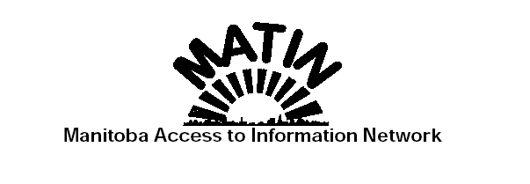March 31, 2004

Honourable Eric Robinson
Minister of Culture, Heritage & Tourism
Room 118
450 Broadway
Winnipeg, Manitoba
R3C 0V8
Dear Minister,

On behalf of the Manitoba Access to Information Network (MATIN), we submit for your review our recommendations for changes to the Province of Manitoba’s Freedom of Information and Privacy Protection Act.

Freedom of information is a fundamental democratic right which enhances timely access to substantive critical government information necessary for the full discussion of policy proposals and for holding governments to account for their actions, inaction and performance. An information deficit is a democratic deficit and results in an unlevel playing field between the Government and its citizens.

The Legislative Assembly expressed its support for freedom of information when it passed the Freedom of Information Act unanimously in 1988. Furthermore, the Legislative Assembly expressed its support for ongoing vigilance on freedom of information by requiring a statutory review by a Legislative Committee of the Freedom of Information Act within three years of its coming into effect which review was never conducted.

The Government of Manitoba has never provided an independent and detailed
review and audit of the Freedom of Information and Protection of Privacy Act
and the government information delivery system even though modern
information technology makes routine disclosure of government information
eminently feasible and cost-effective. The Government of Manitoba has not provided access to the submissions of government departments and agencies for its previous review of the Freedom of Information Act in 1997. They also denied a Freedom of Information access request for these submissions. The current review process makes no provision for access to such critical information again. A proper review requires
information about the suppliers of information not just the users. The discussion paper issued brings forward concerns about such supplier issues as cost, time and procedure but without attribution and documentation. This does not foster and fair and full discussion of the issues.
…/2

The Government of Manitoba has never conducted, or at least disclosed a user
survey on access to government information.

Unlike the recently announced public hearings on the Workers Compensation Act, there is no provision for citizens to view each other's written submissions and exchange ideas via a web site (http://www.wcbactreview.com). The submission review process leaves the Government free to pick and choose advice without being held to account.

The latest annual report on FIPPA from Manitoba Culture, Heritage and Tourism is dated 2002 (released on August 18, 2003) and the 2003 report will not be available before June at the earliest. The latest Annual Report on FIPPA from the Manitoba Ombudsman is 2001 (tabled in April 2003) and the 2002 report, already a year late, will not be released until April 2004 at the earliest.

The Manitoba Ombudsman is in breach of Section 65 of the Freedom of Information and Protection of Privacy Act which requires a 90-day time limit for his investigations. According to the latest 2001 annual report, he carried over 127 complaints from the 260 received in 2001 and has carried over 185 from previous years. A citizen cannot appeal to the Court of Queen's Bench until the Ombudsman has reported on his/her complaint. The annual report does not provide statistics on his performance of this obligation. This is indicative of a complete breakdown of the complaint process.

Modern information technology means there are no technical barriers for routine access to and disclosure of the government information necessary for citizen participation in the policy-making process and for holding the government accountable.

We thank you for the opportunity to engage on this very important public policy process. If you have any questions regarding this submission, please do not hesitate to contact Mr. Paul Nielson at XXX-XXXX.

Sincerely,

Paul Nielson Adrienne Batra
Manitoba Library Association Canadian Taxpayers Federation - Manitoba

Linwood DeLong Arlene Draffin Jones
Manitoba Library Association Provincial Council of Women of Manitoba Inc.

Larry LaLiberte
Manitoba Eco-Network

