Nelson House
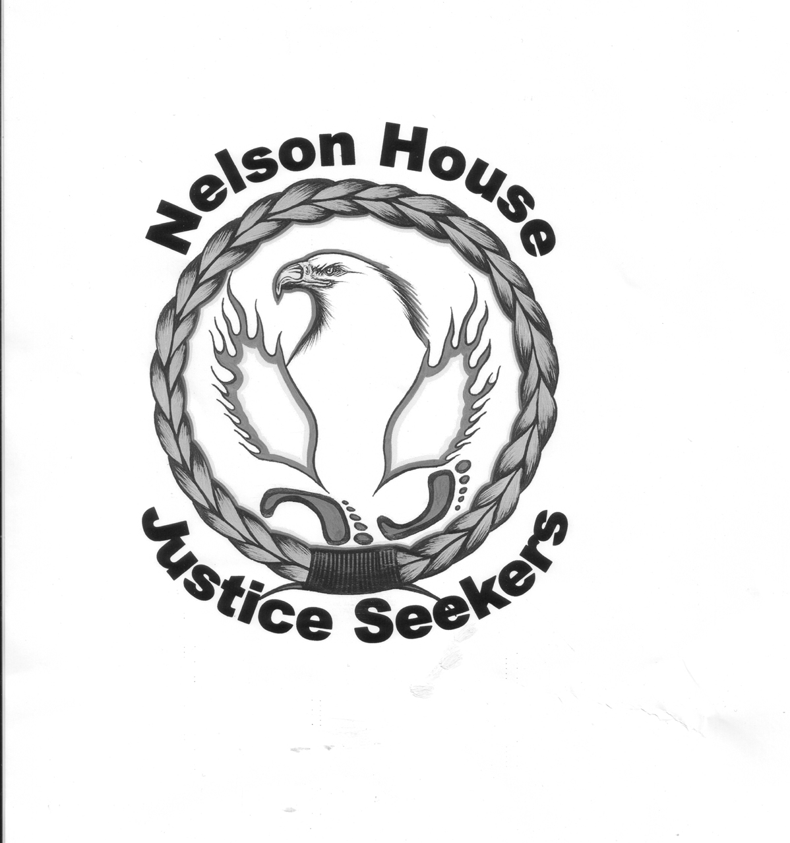
Justice Seekers Boreal Forest Network

WORK PERMIT ISSUED TO HYDRO FOR WUSKWATIM SITE BEFORE MINISTER GIVES ENVIROMENTAL APPROVAL

The Boreal Forest Network

FOR IMMEDIATE RELEASE – July 19, 2004

Reports that Manitoba Hydro has begun site preparation for the Wuskwatim dam, before getting environmental approval for the project, have been reported by Nelson House Justice Seekers to the Boreal Forest Network (BFN).

A work permit has been issued, for Hydrometric Field Work, to Manitoba Hydro by Manitoba Conservation District Office in Thompson. When he asked to see the permit, Don Sullivan, Executive Director of BFN, was told “that we do not give out that information and that a Freedom of Information Request would have to be undertaken in order to obtain the Work Permit issued to Manitoba Hydro”.

“We strongly believe that these types of work permits need to be filed in the Public Registry as there is an urgent need to be transparent. The public has a right to know who is doing what type of activities on Crown Land.”

“Ed Wojcznski looked me in the eye at the Clean Environment Commission, pre hearing conference on Wuskwatim and stated that no work on the access road or construction camp would begin until a decision about the dam is handed down”, said Don Sullivan, Executive Director at BFN.

Wojcznski, of Manitoba Hydro, is clearly on record (July 28, 2003, page. 105) in the Clean Environment Commission pre hearing conference transcripts, as saying that Manitoba Hydro would not proceed with site preparation work before the process had been completed.”

“How is this different than the legacy of broken promises Hydro has been accused of for the last 30 years?” asked Sullivan. “They’ve clearly said one thing and done another in the past and they may be repeating this legacy again in this instance.”

The proposed Wuskwatim project would be developed on Nelson House First Nation’s traditional land. Nelson House (NCN) community members have been assured that they will have the final say as to whether or not the project goes ahead when they vote on it in a formal referendum.

Carol Kobliski is spokesperson for The Justice Seekers of Nelson House, a group formed by community Elders.

“Ed Wojcznski came to Nelson House on June 22 (2003)”, Kobliski said. He stood up and said Hydro wanted a new relationship with the Cree and Nelson House based on trust and respect. How does he think this will happen if they’re already in here cutting without even informing us? People here are very upset”.

“It only goes to show that the hydro leopard hasn’t changed it's spots, and that it's just another repeat of the Churchill River Diversion Project (CRD), broken promises and lies. This is misleading to our people and our community. That hydro and our leaders would allow this to happen when in fact they stated on record that they would wait until everything was finalized is very disheartening”, Kobliski stated.

“We are calling on the Minister of Conservation to issue a cease and desist order until the site has been inspected to ensure work relate to site preparation for Wuskwatim is not being undertaken under the guise of the work permit issued for Hydrometric Field Work. The Minister must provide a full report of activities that Manitoba Hydro is undertaking at the proposed Wuskwatim site to all Public Participants in the Clean Environment Commission Hearings on the proposed Wuskwatim dam”, concluded Kobliski.

For Further Information
Contact:
Carol Kobliski: Justice Seekers of Nelson House this evening at
1-204-484-2350 or during day at 1-204-484-2594

(204) 484-2594

Don Sullivan BFN (204) 947-3081 or cell (204) 949-9393

