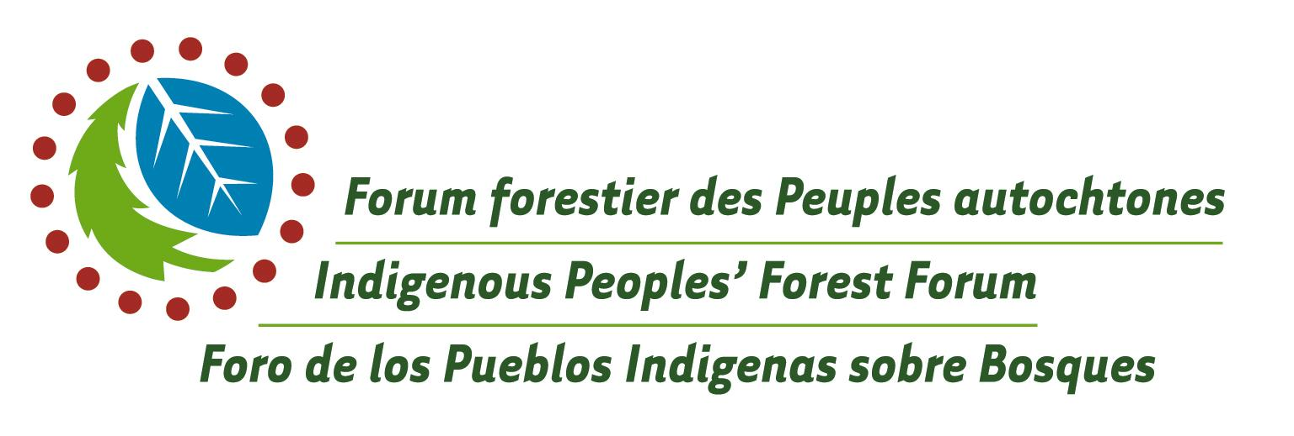

WENDAKE ACTION PLAN

From Indigenous Peoples’ Forest Forum
Huron-Wendat Territory, Province of Quebec
September 2003
Official Event
of the XII World Forestry Congress

WENDAKE ACTION PLAN

From Indigenous Peoples’ Forest Forum
Huron-Wendat Territory, Province of Quebec
September 2003
Official Event
of the XII World Forestry Congress

We, Indigenous Peoples, from different parts of the world, participants of this Indigenous Peoples’ Forest Forum, held on the territory of the Huron-Wendat, in conjunction with the XII World Forestry Congress, September 2003, in the province of Quebec, Canada, re-affirm the multitude of declarations made by Indigenous Peoples so many times since the Earth Summit was celebrated in Rio de Janeiro, Brazil in 1992 and demand that they be acknowledged and implemented.

As was stated in Kari-Oca (1992), Leticia (1996), Kimberley (2002), Cancun (2003) and Durban (2003), we re-affirm our inherent right over our territories, lands and resources. True sustainable development cannot be achieved without full recognition of and respect for our rights as Indigenous peoples and without recognition for and strengthening of our systems of integrated natural resource management. We re-affirm that there is an intimate connection between biodiversity and cultural diversity.

We have developed this action plan based on all our past declarations. This plan also takes into account the progressive elements of other standards, principles, proposals for action and work programs developed and adopted through various international forest related processes and instruments, which deal inter alia with our rights to territories, lands and resources, our right to own and control resources, the obligation to guarantee our meaningful participation in the management of forests, the need to secure our consent, and the equitable sharing of the benefits from the development and use of those resources. It is now time for action.

Since time immemorial, we have respected and looked after our territories, lands and resources. Our survival and the survival of natural ecosystems depends on the recognition of this fact and effective action to respect our rights as Indigenous Peoples. The time for this action is now.

We present this Wendake Action Plan and our previous declarations to this XII World Forestry Congress and urge Nation States, inter-governmental organizations, specialized agencies, international financial institutions and non-governmental organizations to implement the recommendations and demands they contain as a matter of priority.

The Most Important Action Items:

That the United Nations and its bodies and specialized agencies, Nation States, international and regional inter-governmental organizations and international multi-lateral agencies recognize and guarantee Indigenous Peoples’ right to self-determination, including the right to govern the use of natural resources and maintain the integrity of our cultures and ecosystems in accordance with our respective worldviews.

The UN should encourage Nation States to ratify international agreements and conventions which affirm Indigenous Peoples’ rights.

Nation States and inter-governmental organizations must fulfill their respective obligations to recognize, comply with and implement international agreements and treaties, which address Indigenous Peoples’ rights.

Action Needed On:

- Indigenous Rights

- Indigenous rights must be addressed in forest policy at all levels.
- We urge Nation States and intergovernmental organizations to establish mechanisms, with the effective participation of Indigenous Peoples, to assess performance on governmental and inter-governmental commitments and obligations to uphold and respect Indigenous Peoples’ rights.
- The UN, in consultation with the UN Permanent Forum on Indigenous Issues, will recommend to Nation States that they develop, in conjunction with Indigenous Peoples, more effective means to monitor and verify the participation of Indigenous Peoples in forest policy making and sustainable forest management.
- The UN and its specialized agencies and other international multi-lateral and bi-lateral agencies must provide financial support so that Indigenous Peoples can access legal and technical services to assist us to defend and realise our rights in our countries.

- Rights to Resources

- Nation States shall make restitution and pay compensation for past infringement of Indigenous Peoples’ rights and the loss of use of forests and guarantee against any further infringements.
- Nation States shall guarantee the legal recognition and demarcation of Indigenous Peoples’ lands and territories based on the full participation of Indigenous Peoples.
- Nation States with the full participation of Indigenous Peoples will develop mechanisms to ensure the equitable distribution of resources.
- Nation States must recognize and respect the intangibility of the territories of Indigenous Peoples who live in voluntary isolation.

- Consent, Capacity and Meaningful Participation

- Nation States must take transparent measures to guarantee that the free, prior, full and informed consent of Indigenous Peoples is obtained before implementing any decisions or activities that may affect their traditional territories and lands.
- Nation States will work with Indigenous Peoples to develop specific mechanisms that guarantee the full participation of Indigenous Peoples in the process of formulating public policy on forest and land management, protection and development.
- The appropriate bodies such as the UN, Nation States, and international multi-lateral organizations will work with Indigenous Peoples to develop institutional and legal mechanisms that reinforce our own models of community based integrated forest management.
- The UN, Nation States, international multi-lateral organizations and members of the Collaborative Partnership on Forests (CPF) will provide adequate funding to support Indigenous Peoples’ initiatives to develop their capacity to manage forests in accordance with their own traditions and priorities.

- Traditional Forest Related Knowledge and Cultural Rights

- The UN, with the UN Permanent Forum on Indigenous Peoples and inter-governmental agencies will recommend to the Nation States, a framework to promote and protect traditional knowledge, including traditional forest related knowledge.
- Nation States will develop legislation with Indigenous Peoples, which recognizes, and facilitates the protection and use of traditional knowledge by Indigenous Peoples in forest management planning, conservation and development. Such legislation will contain measures to combat biopiracy and the improper use of our traditional knowledge.

- Economic Instruments and Trade Agreements

- Nation States, the World Trade Organization, International Monetary Fund, and the World Bank together with Indigenous Peoples must review and evaluate all new and existing trade related instruments or policies to determine the extent to which they infringe on our rights and threaten our livelihoods.
- Nation States, international multi-lateral organizations must abandon all existing and proposed economic and trade related instruments or policies which infringe or threaten to infringe on our rights.
- The UN and Nation States and international multi-lateral organizations will develop, with Indigenous Peoples, mechanisms to compensate for the provision of environmental services.
- The UN and Nation States and international multi-lateral organizations will provide resources and appropriate processes to support our efforts to fully participate in international trade discussions on issues that affect us.

- Capital Investment and Transfer of Technology

- Nation States and international multi-lateral organizations will implement development programs which give Indigenous Peoples access to financial and technological resources required to facilitate the strengthening of our local forest management systems.

CONCLUDING REMARK

Nation States must stop taking the resources from our territories and lands and must stop using our issues to promote their national goals in the international arena without ensuring that they have fulfilled their commitments at home.

We urge Nation States, inter-governmental organizations, the UN, the Organization of American States, the European Union, specialized agencies such as United Nations Education Social Cultural Organization, Food and Agriculture Organization, World Intellectual Property Organization, World Trade Organization and financial agencies such as the Inter-America Development Bank, World Bank, among other international entities, to adopt these actions as part of their policies and programs and meet the demands of Indigenous Peoples.

